Educator Preparation Provider

Letter of Intent Application
(Revised 01/2024)

TABLE OF CONTENTS

Introduction 3
Directions 4
Overview of Educator Preparation Provider Program Review Process 5
Key Terms 6
Abbreviations 6
Program Information 7
Program Intent 10
Program Justification 12
Program Startup 16
List of Appendices 18
Educator Preparation Provider Verification 19

Introduction
The Hawai'i Teacher Standards Board (HTSB) is the state-authorizing agency that approves and oversees educator preparation programs in Hawai'i (Hawaii Administrative Rules [HAR] §8-54-18).

The purpose of the Educator Preparation Program (EPP) Letter of Intent (LOI) Application is for institutions or organizations interested in implementing an initial license or add a teaching field teacher licensure program. The LOI application shall be used by Hawai'i-approved and non-Hawai'i-approved programs.

According to HAR §8-54-20:
- When applying for approval of a first-time provisional unit or program review, the following requirements shall be met:
(1). The letter of intent and preconditions must be submitted for consideration no less than one (1) year prior to the date of proposed program implementation; and
(2). Within two (2) years of acceptance of the letter of intent and preconditions, the unit must submit one (1) unit report and a program report for each program that will prepare educators for initial licensure.
- The board staff will convene a review team and conduct a virtual provisional review of the unit and programs within three (3) months of acceptance of the unit and program reports after staff review and board approval.
- The board will review the review team's recommendation and issue a decision upon recommendation of the board's Teacher Education Committee.
- A unit must receive board approval before advertising programs for initial licensure, implementing programs, and accepting candidates into any educator preparation program.

Please direct any inquiries about the process to the following HTSB staff:

Executive Director: Felicia Villalobos
Email: felicia.villalobos@hawaii.gov

Licensing Specialist: Dr. Jennifer Padua
Email: jennifer.padua@hawaii.gov

Directions
- Please read the entire application and complete all prompts. All questions must be answered. Incomplete applications and/or missing appendices will be returned.
- This application is designed for initial licensure or the add a teaching field program. If you have an existing Hawai'i-approved program and are making changes, please contact the HTSB Executive Director to determine if you should submit a Program Modification application.
- HTSB will not accept any URLs or direct links to information. Please describe any information within the prompt. The prompt requesting the public website page may be a live URL.
- Save the file as InstitutionName_LOI_LicenseFieldName_date.
- Please submit a copy of the LOI in Microsoft Word and PDF to the email below. Submit all appendices as a PDF file.

Executive Director: Felicia Villalobos
Email: felicia.villalobos@hawaii.gov

Licensing Specialist: Jennifer Padua, Ph.D.
Email: jennifer.padua@hawaii.gov

Overview of Educator Preparation Provider Program Review Process

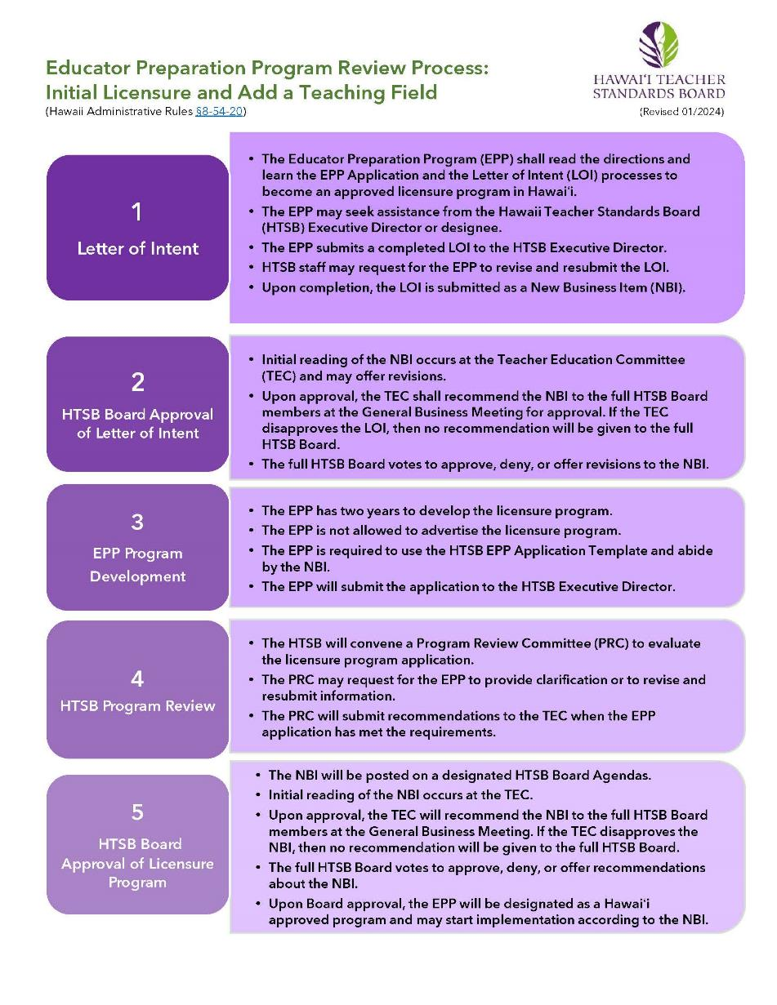

Key Terms

Term | Definition
Add a Field Program | Add a Field programs are designed to prepare existing licensed educators to add another licensure field to their current license (§8-54-24).
Alternative Certification Program | Alternative certification program is a for-profit or non-profit organization offering a teacher licensure program for individuals who have earned a baccalaureate degree.
Alternative Route | A teacher preparation program at an institution of higher education that offers a pathway to initial teacher licensure for individuals who have earned a baccalaureate degree.
Educator Preparation Provider | An organization, college, or university that provides a teacher licensure program for future or current teachers.
Institute of Higher Education | An institution of higher education (IHE) is a college or university that offers post-secondary courses for individuals interested in earning an academic degree.
Teacher Candidate | A college student or an Emergency Hire Teacher enrolled in a teacher education program and pursuing a teacher license.
Traditional Program | A traditional program at an IHE that offers a state-approved teacher education program where teacher candidates will earn an academic degree and teacher licensure recommendation upon successful program completion.

Abbreviations

Abbreviation | Meaning
ACP | Alternative Certification Program
B.A. | Bachelor of Arts
BS | Bachelor of Science
BEd | Bachelor of Education
EPP | Educator Preparation Provider
HTSB | Hawaiʻi Teacher Standards Board
HIDOE | Hawaiʻi Department of Education
HIPCS | Hawaiʻi Public Charter School
IHE | Institution of Higher Education
LOI | Letter of Intent
MA | Master of Arts
MEd | Master of Education
MEdT | Master of Education in Teaching
MS | Master of Science
PB-Cert | Post-baccalaureate Certificate
SATEP | State Approved Teacher Education Program
TEC | Teacher Education Committee

Program Information

Institution Name
Mailing Address*
Public URL/Website
*If your institution does not have a physical presence in Hawaiʻi, explain how teacher candidates will receive prompt in-person support (§16-255-2).

Institution Administrator
Title
Email Address
Phone Number

EPP Administrator Name (if different from Institution Administrator)
Position
Phone
Email

EPP Liaison for HTSB Communication
Name
Position
Phone
Email

Mark an X next to the option that best describes your institution.
Institution of Higher Education, Public College or University
Institution of Higher Education, Private/Independent
Alternative Certification Pathway, For-profit
Alternative Certification Pathway, Non-profit (501/503c)

Provide your institution's vision, mission, and goals.

Describe the history and development of your EPP to help the reviewers understand the context of your institution. Include information about the age, history, and distinguishing features (1000 words).

Are you an approved EPP in other U.S. states or jurisdictions? If yes, please include the states, approved licensure fields, and grade span.

Provide a summary of the demographics (e.g., enrollment, diversity, full-time, part-time) of students and faculty in your EPP (300 words).

Please read the following prompts and mark an X in the Yes or No column. | YES | NO
Is your institution approved by the Council for Higher Education Association?
Is your institution registered with the Hawaiʻi Post-secondary Education Authorized Program?

Is your IHE or Alternative Certification Program (ACP) currently approved by the HTSB?

Does a United States regional accreditor approve your institution?
If yes, attach a copy of the institution's current accreditation letter, including status and expiration date.
Does a U.S. teacher educator program accreditor approve your educator preparation program? If yes, attach a copy of the institution's current accreditation letter, including status and expiration date.
Are any of your programs accredited by the Distance Education Accrediting Commission? If yes, attach a copy of the institution's current accreditation letter, including status and expiration date.
Is any of your programs accredited by other U.S. accreditors not listed above? If yes, attach a copy of the institution's current accreditation letter, including status and expiration date.
Has your program received approval as a Hawai’i Department of Education (HIDOE) Affiliate Program to place teacher candidates in its school? If yes, please attach a copy of your HIDOE Educator Affiliation Agreement.

Program Intent
Mark an X next to one of the licensure program for which you plan to submit a program review application.

Licensure Program | Select One
Initial Licensure – IHE Traditional Route
Teacher candidates will earn an academic degree from an accredited IHE and be recommended for a teaching license upon successfully completing the EPP. Teacher candidates will earn college credits.
Initial Licensure - IHE Alternative Route
Teacher candidates have earned an undergraduate degree from an accredited IHE and will be recommended for a teaching license upon successfully completing the program. Teacher candidates will earn college credits.
Initial Licensure – ACP
Teacher candidates enrolled in an ACP program. They have earned an undergraduate degree from an accredited IHE and will be recommended for a teaching license upon completing the ACP. Teacher candidates do not earn college credits.
Add A Field Program - IHE
Teacher candidates hold a valid teaching license from the Hawai'i Teacher Standards Board. Upon successfully completing the program, they will receive a recommendation for a specific licensure field. Teacher candidates earn college credits.
Add A Field Program - ACP
Teacher candidates hold a valid teaching license from the Hawai'i Teacher Standards Board. Upon successfully completing the ACP, they will receive a recommendation for a specific licensure field. Teacher candidates do not earn college credits.

List the licensure field for approval.  List of HTSB-approved licensure fields | List the grade level span for the licensure field. | If IHE, list the academic degree or certificate the completers will earn. Write N/A if needed.

Read the following prompts and mark an X in the Yes or No column if you anticipate implementing your program using the instructional delivery modes. | YES | NO
Face-to-face: in-person at a physical location
Blended: face-to-face and online learning
Online: synchronous learning
Online: asynchronous learning
Online Hybrid: synchronous and asynchronous
Other (please describe):

Program Justification

Briefly describe your proposed program, licensure program, and grade level span (300 words maximum).

Describe how your proposed program will address the HIDOE and HIPCS educational needs and strategic plans. Cite quantitative and qualitative data and academic research to support your response (500 words maximum).

Explain how your proposed licensure field program will complement and address any challenges with existing Hawaiʻi approved programs. Cite quantitative and qualitative data and academic research to support your response (500 words maximum).

If you are an EPP, explain how this licensure program will enhance your existing licensure programs and not compete with similar licensure programs being implemented. Cite quantitative and qualitative data and academic research to support your response (500 words maximum).

Describe how you plan to select, prepare, evaluate, support, and retain partnership schools (300 words maximum).

If you do not have existing partnerships with the HIDOE or HIPCS, what is your plan to establish these partnerships? (300 words maximum).

Provide a list of existing HIDOE or HIPCS partnerships. Write none if you do not have any partnerships.
Island | Complex Area | School Name
Hawaiʻi
Kauaʻi
Lānaʻi
Maui
Molokaʻi
Oʻahu

If you are a Hawaii-approved program, please provide quantitative data on the number of program completers who have received a teacher license from the HTSB within the past six years and are currently teachers in the HIDOE or HIPCS.
Completer Year | Number of program completers | Number of teachers currently employed in the HIDOE | Number of teachers currently employed in the HIPCS

Describe how you plan to select, prepare, evaluate, support, and retain cooperating/mentor teachers to ensure teacher candidates are developing in their licensure field (300 words maximum).

How will your cooperating/mentor teachers be compensated (e.g., financial, professional development courses)? (300 words maximum)

Program Startup

How many months do you anticipate a teacher candidate will need to complete your licensure program?

What are the anticipated costs a teacher candidate will pay annually and the total cost upon program completion?

Will this licensure program provide tuition assistance for teacher candidates?
If yes, please explain the funding source, requirements to receive funding, and any payback obligations (e.g., teaching for specified years or exiting the program without successful completion).

What professional liability insurance do you anticipate teacher candidates will need to obtain throughout the program?

What anticipated recruitment strategies do you anticipate using to enroll teacher candidates in the program?

What time of the year do you anticipate candidates can apply to the program? What time of the year will teacher candidates start the program?

How many candidates do you anticipate enrolling in your licensure program in its first year of operation?

Explain the current employment outlook and how your proposed licensure program will support completers in the job market upon exiting your program and sustaining itself for the next 3-5 years. Cite data and academic research to support your response (300 words maximum).

List of Appendices
Please support the LOI with the following appendices as separate PDF attachments. You may add additional appendices if needed.

Save the file name as InstitutionName_LicenseFieldName_AppendixLetter_date.pdf

Appendix A: A copy of the institution organization chart and the educator preparation program organization chart.

Appendix B: A copy of current accreditation letters from the United States regional institution accreditor, teacher education program accreditor, and other accreditors such as the Distance Education Accrediting Commission.

Appendix C: A copy of the HIDOE Affiliate Program Agreement

Appendix D: List of data sources and dates collected.

Appendix E: Reference of academic literature or academic research formatted in APA 7th edition.

Educator Preparation Provider Verification

Preparer’s Information
Name
Position
Telephone Number
Email

Contact person should there be any questions about the application.
Name
Position
Telephone Number
Email

I verify that the contents of this application are complete, accurate, and approved by the institution/organization administrator. Please use an ink or digitally stamped signature.
Name
Date

