

Educator Preparation Provider

Program Modification Application

**Table of Contents**

Introduction 3

Directions 4

Overview of Educator Preparation Provider Modification Process 5

Key Terms 6

Abbreviations 7

EPP Information 8

EPP Modification Change 9

Types of Program Modification 10

Program Course Comparison 12

Content Knowledge and Pedagogy Requirements (Coursework) 13

Content Knowledge and Pedagogy Requirements (Modules) 14

List of Appendices 15

Educator Preparation Program Verification 16

# Introduction

The Hawai'i Teacher Standards Board (HTSB) is the state authorizing agency that approves and oversees educator preparation programs in Hawai'i (Hawaii Administrative Rules [HAR] [§8-54-18](https://hawaiiteacherstandardsboard.org/content/wp-content/uploads/HTSB_HAR-Signed-9_5_19-1.pdf)) and to approve modifications made by the Educator Preparation Provider (EPP) ([HAR §8-54-27](https://hawaiiteacherstandardsboard.org/content/wp-content/uploads/HTSB_HAR-Signed-9_5_19-1.pdf)). There are three types of modifications with distinct processes.

1. **Program Elimination.**  An EPP will no longer provide a pathway for a designated licensure field. To submit a program elimination modification request, the EPP shall submit in writing on the EPP official letterhead addressed to the HTSB Board Chair and HTSB Executive Director. The letter shall include:
   1. the licensure program and licensure fields that will be eliminated;
   2. reasons for elimination;
   3. assurances on how the EPP will support any currently enrolled candidates to complete the program;
   4. the effective date of program elimination; and
   5. the name and contact information representing the EPP should there be any questions.
2. **Minor Modifications.** An EPP has changed the approved licensure program, but that change does not substantively alter the program. Please read the list of EPP and program changes to determine if they are minor or major modifications. To submit a minor modification request, the EPP shall submit the modification in their HTSB Annual Report.
3. **Major Modifications.** An EPP has made substantive changes to the approved licensure programs. These substantive changes are in the following areas:
   1. EPP Change(s)
      1. EPP name
      2. EPP organization/structure.
      3. EPP ownership or legal status.
      4. EPP vision, mission, and goals.
   2. Program Change(s)
      1. Degree level or licensure pathway of the program (e.g., switching from an academic degree to a certificate program, initial licensure to Add a Teaching Field).
      2. Core curriculum (e.g., sequence of instruction, changes in verifying content knowledge, basic skills, and Hawaiʻi specific requirements, adjustment of credit hours for program completion).
      3. Courses (e.g., adding, deleting, replacing courses).
      4. Clinical experiences (e.g., sequence, structure, or length of clinical experience to meet the Hawaiʻi requirement) .
      5. Change in grade level span (e.g., adding/removing grade level span such as preschool from elementary education, adding/dividing K-12 to K-6 or 6-12).
      6. Other (described by the EPP).

To submit a major modification request, the EPP shall use the major modification application template. If your program is changing the grade level spans, you must submit an EPP Program Modification Application.

# Directions

1. Please read the entire application and complete all prompts. Incomplete applications and missing appendices will be returned.
2. This application is designed for EPP and program modifications to existing licensure programs. If your program is adding a new grade level span, you must submit a new EPP Initial Licensure Program Application
3. HTSB will not accept any URLs or direct links to information. The HTSB can provide a shared folder to upload documents.
4. Please describe any information within the prompt and given word count. The prompt requesting the public website page may be submitted as a live URL.
5. Save the file as InstitutionName_Modification_LicenseFieldName_date.
6. Additional evidence/documents may be requested.
7. Please submit a copy of the program modification application in Microsoft Word and PDF to the emails below. All appendices shall be submitted as a PDF file.

Executive Director: Felicia Villalobos

Email: felicia.villalobos@hawaii.gov

Licensing Specialist: Dr. Jennifer Padua

Email: jennifer.padua@hawaii.gov

# Overview of Educator Preparation Provider Modification Process

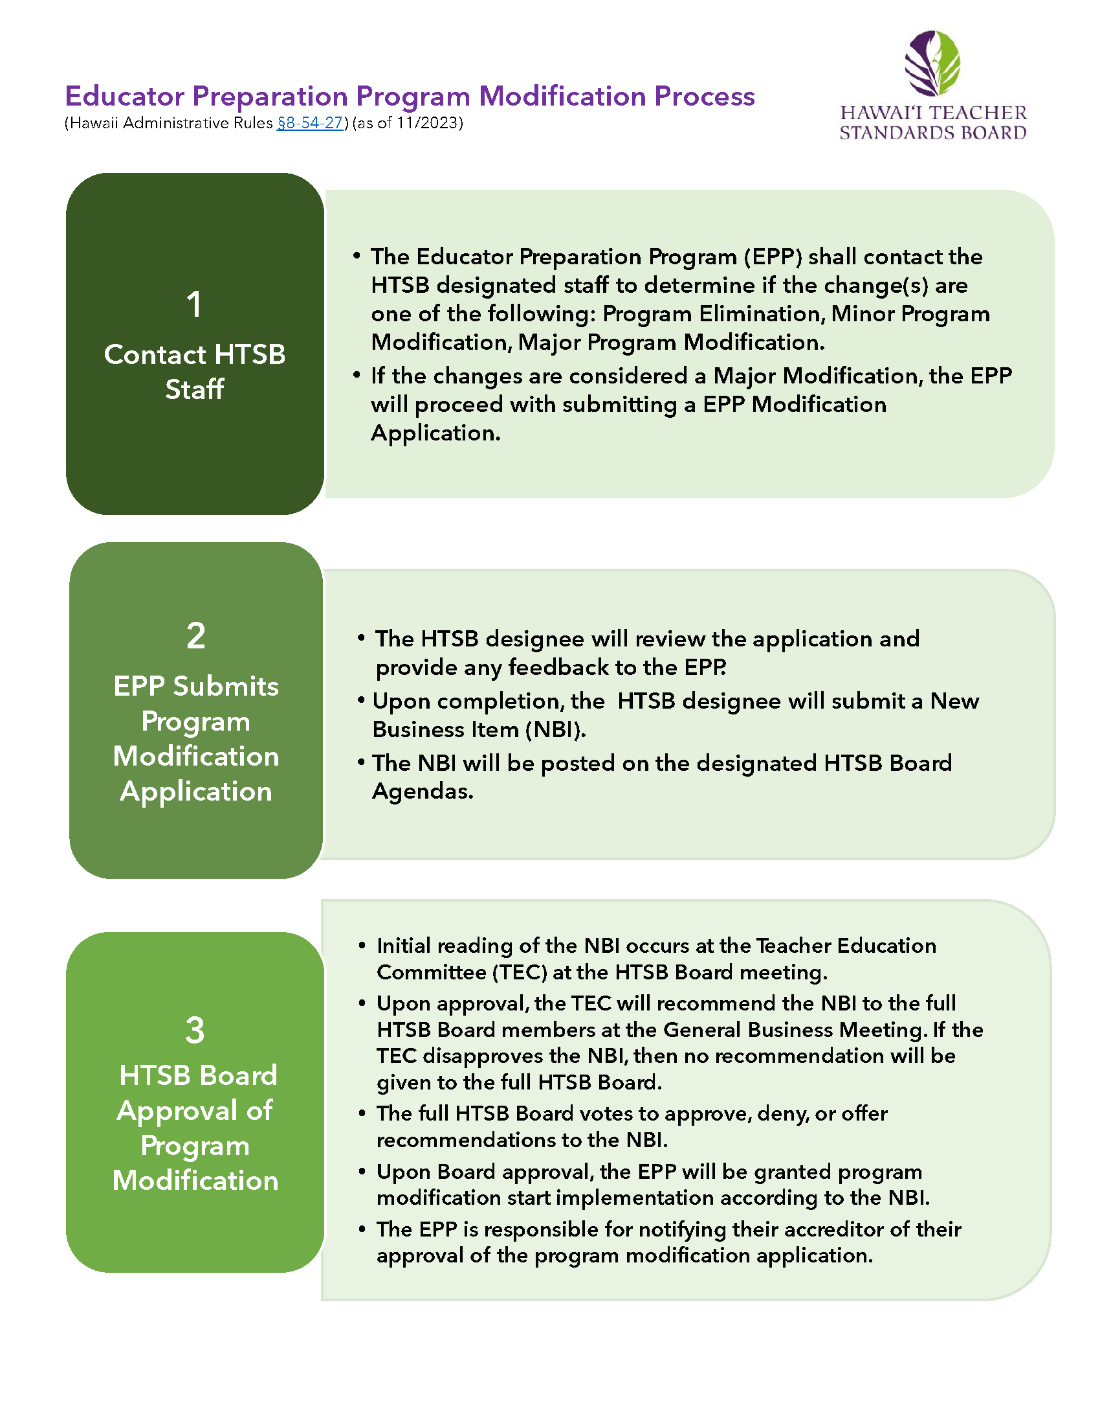

# Key Terms

|  |  |
| --- | --- |
| **Term** | **Definition** |
| Add a Field Program | Add a Field programs are designed to prepare existing licensed educators to add another licensure field to their current license (§8-54-24). |
| Alternative Certification Program | Alternative certification program is a for-profit or non-profit organization offering a teacher licensure program for individuals who have earned a baccalaureate degree. |
| Alternative Route | A teacher preparation program at an institution of higher education that offers a pathway to initial teacher licensure for individuals who have earned a baccalaureate degree. |
| Clinical Experience | The culminating activity of extended teaching practice for teacher candidates. Clinical experience may be referred to as student teaching, internship, or residency. |
| Educator Preparation Provider | An organization, college, or university that provides a teacher licensure program for future or current teachers. |
| Emergency Hire | An unlicensed employee of a public or public charter school paid under the salary schedule contained in the Unit 05 collective bargaining agreement. An Emergency Hire teacher is usually the teacher of record. |
| Institute of Higher Education | An institution of higher education (IHE) is a college or university that offers post-secondary courses for individuals interested in earning an academic degree. |
| National Accreditor | An agency that accredits schools or programs offering certification or degrees in the United States (US). |
| Program Accreditor | An agency that evaluates the quality of professional preparation programs. |
| Regional Accreditor | An agency that focuses on the quality of academic programs in state-owned or non-profit colleges or universities in a specific region of the US. |
| Teacher Candidate | A college student or an Emergency Hire Teacher enrolled in a teacher education program and pursuing a teacher license. |
| Teacher of Record | An educator who has been assigned the lead responsibility for a student's learning and performance. |
| Traditional Program | A traditional program at an IHE that offers a state-approved teacher education program where teacher candidates will earn an academic degree and teacher licensure recommendation upon successful program completion. |

# Abbreviations

|  |  |
| --- | --- |
| **Abbreviation** | **Meaning** |
| ACP | Alternative Certification Program |
| BA. | Bachelor of Arts |
| BS | Bachelor of Science |
| BEd | Bachelor of Education |
| EPP | Educator Preparation Provider |
| HAR | Hawai'i Administrative Rules |
| HTSB | Hawai'i Teacher Standards Board |
| HIDOE | Hawai'i Department of Education |
| HIPCS | Hawai'i Public Charter School |
| IHE | Institution of Higher Education |
| HRS | Hawai'i Revised Statute |
| LOI | Letter of Intent |
| MA | Master of Arts |
| MEd | Master of Education |
| MEdT | Master of Education in Teaching |
| MS | Master of Science |
| NBI | New Business Item |
| PB-Cert | Post-baccalaureate Certificate |
| SATEP | State Approved Teacher Education Program |
| TECC | Teacher Education Coordinating Committee |
| US | United States |

# EPP Information

|  |  |
| --- | --- |
| Institution Name |  |
| Mailing Address |  |
| Public URL/Website |  |

|  |  |
| --- | --- |
| Institution Administrator |  |
| Title |  |
| Email Address |  |
| Phone Number |  |

|  |  |
| --- | --- |
| EPP Administrator Name (if different from Institution Administrator) |  |
| Position |  |
| Phone |  |
| Email |  |

|  |  |
| --- | --- |
| EPP Liaison for HTSB Communication |  |
| Name |  |
| Position |  |
| Phone |  |
| Email |  |

# EPP Modification Change

|  |  |  |
| --- | --- | --- |
| Mark an X next to the type of EPP Modification(s) requested in this application. | | |
| EPP Modification(s) | YES | NO |
| EPP name |  |  |
| EPP organization/structure |  |  |
| EPP ownership or legal status |  |  |
| EPP vision, mission, and goals |  |  |

|  |
| --- |
| Provide a narrative describing the EPP changes and rationale. Please include the timeframe for these changes and how these changes will impact current staff and students. If needed, upload additional documents as appendices to support your narrative (maximum 500 words). |
|  |

|  |
| --- |
| Provide a narrative on how faculty and students will be informed of the EPP changes in a timely manner. If needed, upload additional documents as appendices to support your narrative (maximum 500 words). |
|  |

# Types of Program Modification

|  |  |  |
| --- | --- | --- |
| Mark an X next to the type of program modification(s) requested in this application. | YES | NO |
| Degree level or licensure pathway of the program (e.g., switching from an academic degree to a certificate program, initial licensure to Add a Teaching Field).  If yes, provide an explanation. |  |  |
| Core curriculum (e.g., sequence of instruction, changes in verifying content knowledge, basic skills, and Hawaiʻi specific requirements, adjustment of credit hours for program completion).  If yes, provide an explanation. |  |  |
| Courses (e.g., adding, deleting, replacing courses).  If yes, provide an explanation. |  |  |
| Clinical experiences (e.g., sequence, structure, or length of clinical experience to meet the Hawaiʻi requirement).  If yes, provide an explanation. |  |  |
| Change in grade level span (e.g., adding/removing grade level span such as preschool from elementary education, adding/dividing K-12 to K-6 or 6-12).  If yes, provide an explanation. |  |  |
| Other:  If yes, provide an explanation. |  |  |

|  |
| --- |
| Provide a narrative and rationale describing each program modification. Please include the timeframe for these changes and how these changes will impact current staff and students. If needed, upload additional documents as appendices to support your narrative (maximum 500 words). |
|  |

# Program Course Comparison

|  |
| --- |
| In the space below, provide a comparison table showing the modification from the existing program to the revised program (see the example below). Submit as appendices, the previous course(s), and new course(s) syllabi as well as other documents to support your program modification. Please contact HTSB if you would like a link to a shared digital folder to upload documents. |

Example of Course Comparison Modification Table. If needed, you may delete this table.

|  |  |  |
| --- | --- | --- |
| Current Coursework | Proposed Coursework | Rationale for Course Modification |
| ED639: Leadership through Action Research for School Improvement | ED417: Educational Foundations and Systems in the United States | Based on course evaluations, post-baccalaureate teacher candidates requested a deeper understanding of school systems since most of them did not have undergraduate degrees in education. |
| Total Credits: 3 | Total Credits: 3 |  |

## Content Knowledge and Pedagogy Requirements (Coursework)

This table is intended for programs using a course alphabet and numbering system to outline the courses (e.g., ED360) in the modified sequence of completion. In the table below, write the alphabet and number, course title, estimated completion time, and number of credits that will be earned. Add more rows if needed. Write N/A if your program does not use a course alphabet and numbering system. Please contact HTSB if you would like a link to a shared digital folder to upload documents.

|  |  |  |  |
| --- | --- | --- | --- |
| Course Alpha and Number | Course Title | Estimated Completion Time  (Duration: weeks/semester) | Course Credits |
|  |  |  |  |
|  |  |  |  |
|  |  |  |  |
|  |  |  |  |
|  |  |  |  |
|  |  |  |  |
|  |  |  |  |
|  |  |  |  |
|  |  |  |  |
|  |  |  |  |
|  |  |  |  |
|  |  |  |  |
|  |  |  |  |
|  |  |  |  |

## Content Knowledge and Pedagogy Requirements (Modules)

This table is intended for programs using a module system to outline the courses in the modified sequence of completion. If a module has several lessons, please use a decimal number system to distinguish each lesson. For example, if Module 1 has five lessons, then the lessons would be labeled as 1.1, 1.2., 1.3., 1.4. 1.5. Please write the title for each module (and lesson if applicable) and the estimated completion time. Please contact HTSB if you would like a link to a shared digital folder to upload documents. Write N/A if your program does not use a module system.

|  |  |  |
| --- | --- | --- |
| Module/  Lesson number | Title | Estimated Completion Time (Duration: days/weeks) |
|  |  |  |
|  |  |  |
|  |  |  |
|  |  |  |
|  |  |  |
|  |  |  |
|  |  |  |
|  |  |  |
|  |  |  |
|  |  |  |
|  |  |  |
|  |  |  |
|  |  |  |
|  |  |  |

# List of Appendices

Write a title for each appendix you will submit to support the program modification application. The original application approval will be Appendix A.

Save each appendix using the file name: InstitutionName_Modification_LicenseFieldName-AppendixLetter_date. Submit each appendix in PDF.

Appendix A: (Provide the original program application approval)

Appendix B:

Appendix C:

# Educator Preparation Program Verification

Preparer’s Information

|  |  |
| --- | --- |
| Name |  |
| Position |  |
| Telephone Number |  |
| Email |  |

Contact person should there be any questions about the application.

|  |  |
| --- | --- |
| Name |  |
| Position |  |
| Telephone Number |  |
| Email |  |

**I verify that the contents of this application are complete and accurate, and approved by the institution/organization administrator.**

|  |  |
| --- | --- |
| ***Name*** |  |
| ***Date*** |  |