

Educator Preparation Provider

Letter of Intent Application:

Add a Teaching Field

(Revised 10/2024)

**TABLE OF CONTENTS**

Introduction 3

Directions 4

Educator Preparation Provider Program Review Process 5

Key Terms 6

Abbreviations 7

Program Information 8

Program Intent 11

Program Justification 13

Clinical Experience 15

Program Startup 17

List of Appendices 19

Educator Preparation Provider Verification 20

# Introduction

The Hawai'i Teacher Standards Board (HTSB) is the state-authorizing agency that approves and oversees educator preparation programs in Hawai'i (Hawaii Administrative Rules [HAR] [§8-54-18](https://hawaiiteacherstandardsboard.org/content/wp-content/uploads/HTSB_HAR-Signed-9_5_19.pdf)).

The purpose of the Educator Preparation Program (EPP) Letter of Intent (LOI) Application is for institutions or organizations interested in implementing an Add a Teaching Field (ATF) teacher licensure program. Hawai'i-approved and non-Hawai'i-approved programs shall use the LOI application.

According to Hawaii Administrative Rules:

[HAR §8-54-20](https://hawaiiteacherstandardsboard.org/content/wp-content/uploads/HTSB_HAR-Signed-9_5_19.pdf):

(a) When applying for approval of a first-time provisional unit or program review, the following requirements shall be met:

(1). The letter of intent and preconditions must be submitted for consideration no less than one (1) year prior to the date of proposed program implementation; and

(2). Within two (2) years of acceptance of the letter of intent and preconditions, the unit must submit one (1) unit report and a program report for each program that will prepare educators for initial licensure.

(b) The board staff will convene a review team and conduct a virtual provisional review of the unit and programs within three (3) months of acceptance of the unit and program reports after staff review and board approval.

(c) The board will review the review team's recommendation and issue a decision upon recommendation of the board's Teacher Education Committee.

(d) A unit must receive board approval before advertising programs for initial licensure, implementing programs, and accepting candidates into any educator preparation program.

[HAR §8-54-2.4](https://hawaiiteacherstandardsboard.org/content/wp-content/uploads/HTSB_HAR-Signed-9_5_19.pdf):

(e) the EPP will be charged a $500 Review fee for each license field.

The review fee must be paid 30 days after receipt of the LOI application.

Please direct any inquiries about the process to the following HTSB staff:

Executive Director: Felicia Villalobos

Email: felicia.villalobos@hawaii.gov

Licensing Specialist: Dr. Jennifer Padua

Email: jennifer.padua@hawaii.gov

# Directions

1. Please read the entire application and complete all prompts. All questions must be answered. Incomplete applications and/or missing appendices will be returned.
2. This application is designed for the ATF licensure program. If you have an existing ATF Hawai'i-approved program and are making changes, please contact the HTSB Executive Director to determine if you should submit a Program Modification application.
3. HTSB may accept limited embedded URLs or can set up a file-sharing folder for documents to be uploaded directly. Please describe any information within the prompt. The prompt requesting the public website page may be a live URL.
4. Save the file as InstitutionName_LOI_ATF_LicenseFieldName_date.
5. Please submit a copy of the LOI in Microsoft Word and PDF to the email below. Submit all appendices as a PDF file.

Executive Director: Felicia Villalobos

Email: felicia.villalobos@hawaii.gov

Licensing Specialist: Jennifer Padua, Ph.D.

Email: jennifer.padua@hawaii.gov

# EPP Review Process: Add a Teaching Field

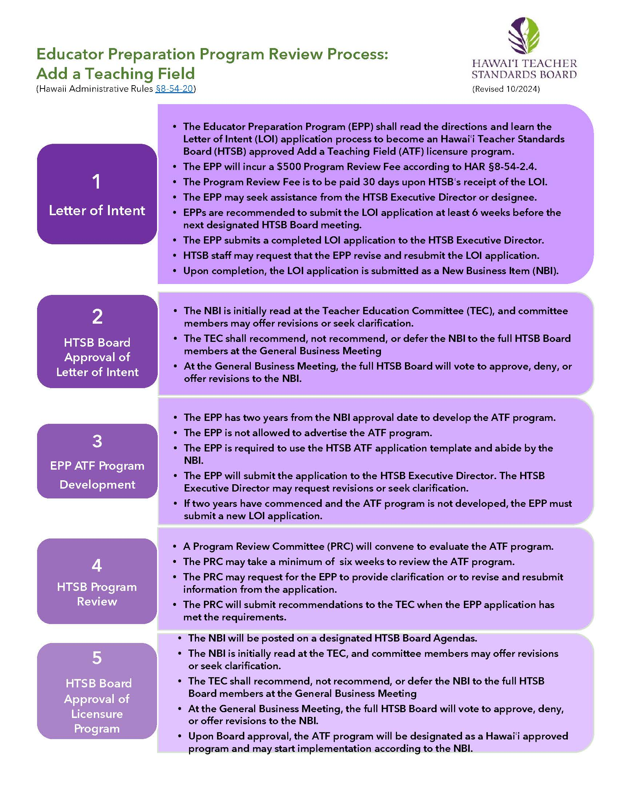

(Hawaii Administrative Rules §8-54-20)

# Key Terms

|  |  |
| --- | --- |
| **Term** | **Definition** |
| Add a teaching field program | An add a teaching field program prepares existing licensed educators to add another teaching field to their valid license (§8-54-24). |
| Alternative certification program | Alternative certification program is a for-profit or non-profit organization that offers a teacher licensure program for individuals who have earned a baccalaureate degree from another institution. |
| Alternative route | A teacher preparation program at an institution of higher education that offers a pathway to initial teacher licensure for individuals who have earned a baccalaureate degree. |
| Educator preparation provider | An organization, college, or university that provides a teacher licensure program for future or current teachers. |
| Enrolled student | An enrolled student is a licensed teacher accepted in the ATF licensure program. |
| Institute of higher education | An institution of higher education (IHE) is a college or university that offers post-secondary courses for individuals interested in earning an academic degree. |
| Teacher candidate | A college student or an Emergency Hire Teacher enrolled in a teacher education program and pursuing a teacher license. |
| Traditional program | A traditional program at an IHE that offers a state-approved teacher education program where teacher candidates will earn an academic degree and a teacher licensure recommendation upon successful program completion. |

# Abbreviations

|  |  |
| --- | --- |
| **Abbreviation** | **Meaning** |
| ACP | Alternative Certification Program |
| ATF | Add a Teaching Field |
| B.A. | Bachelor of Arts |
| BS | Bachelor of Science |
| BEd | Bachelor of Education |
| EPP | Educator Preparation Provider |
| HTSB | Hawaiʻi Teacher Standards Board |
| HIDOE | Hawaiʻi Department of Education |
| HIPCS | Hawaiʻi Public Charter School |
| IHE | Institution of Higher Education |
| LOI | Letter of Intent |
| MA | Master of Arts |
| MEd | Master of Education |
| MEdT | Master of Education in Teaching |
| MS | Master of Science |
| PB-Cert | Post-baccalaureate Certificate |
| PRC | Program Review Committee |
| SATEP | State Approved Teacher Education Program |
| TECC | Teacher Education Coordinating Committee |

# Program Information

|  |  |
| --- | --- |
| Institution Name |  |
| Mailing Address* |  |
| Public URL/Website |  |
| *If your institution does not have a [physical presence](https://cca.hawaii.gov/wp-content/uploads/2013/07/255-C.pdf) in Hawaiʻi, explain how enrolled students will receive prompt in-person support and HTSB licensure requirements (§16-255-2). |  |

|  |  |
| --- | --- |
| Institution Administrator |  |
| Title |  |
| Email Address |  |
| Phone Number |  |

|  |  |
| --- | --- |
| EPP Administrator Name (if different from Institution Administrator) |  |
| Position |  |
| Phone |  |
| Email |  |

|  |  |
| --- | --- |
| EPP Liaison for HTSB Communication |  |
| Name |  |
| Position |  |
| Phone |  |
| Email |  |

|  |  |
| --- | --- |
| Mark an X next to the option that best describes your institution. | |
| Institution of Higher Education, Public College, or University |  |
| Institution of Higher Education, Private/Independent |  |
| Alternative Certification Pathway, For-profit |  |
| Alternative Certification Pathway, Non-profit (501/503c) |  |

|  |
| --- |
| Provide your institution's vision, mission, and goals. |
|  |

|  |
| --- |
| Describe the history and development of your EPP to help the reviewers understand the context of your institution. Include information about the age, history, and distinguishing features (1000 words). |
|  |

|  |
| --- |
| Are you an approved EPP in other U.S. states or jurisdictions? If yes, please list the states, all approved teacher licensure fields and grade span. |
|  |

|  |
| --- |
| Provide a summary of students and faculty demographics (e.g., enrollment, diversity, full-time, part-time) in your EPP (300 words). |
|  |

| Please read the following prompts and mark an X in the Yes or No column. | YES | NO |
| --- | --- | --- |
| Is your institution approved by the [Council for Higher Education Association?](https://www.chea.org/) |  |  |
| Is your institution registered with the [Hawaiʻi Post-secondary Education Authorized Program](https://cca.hawaii.gov/hpeap/)? |  |  |
| Does the HTSB currently approve your IHE or Alternative Certification Program (ACP)? |  |  |
| Does a United States **regional accreditor** approve your institution?  If yes, attach a copy of the institution's current accreditation letter, including status and expiration date. |  |  |
| Does a U.S. teacher educator program accreditor approve **your educator preparation program?** If yes, attach a copy of the institution's current accreditation letter, including status and expiration date. |  |  |
| Are any of your programs accredited by the Distance Education Accrediting Commission? If yes, attach a copy of the institution's current accreditation letter, including status and expiration date. |  |  |
| Is any of your programs accredited by other U.S. accreditors not listed above? If yes, attach a copy of the institution's current accreditation letter, including status and expiration date. |  |  |
| Has your program received approval as a [Hawai’i Department of Education (HIDOE) Affiliate Program](https://sites.google.com/hidoeohr.k12.hi.us/program-affiliation-agreements/Home?authuser=0) to place teacher candidates in its school? If yes, please attach a copy of your HIDOE Educator Affiliation Agreement. |  |  |

# Program Intent

Mark an X next to the proposed ATF licensure program.

|  |  |
| --- | --- |
| **Licensure Program** | **Select One** |
| **Add A Field Program - IHE**  Enrolled students hold a valid teaching license from the HTSB. Upon successfully completing the program, they will receive a recommendation for a specific licensure field. Enrolled students earn college credits. |  |
| **Add A Field Program - ACP**  Enrolled students hold a valid teaching license from the HTSB. Upon successfully completing the ACP, they will receive a recommendation for a specific licensure field. Enrolled students do not earn college credits. |  |

|  |  |  |
| --- | --- | --- |
| List the ATF teacher license field requested for approval.  [List of HTSB-approved licensure fields](https://hawaiiteacherstandardsboard.org/content/wp-content/uploads/License-Fields-11-19-22-ti.pdf) | List the grade level span for the licensure field. | If IHE, list the academic degree or certificate the completers will earn. Write N/A if needed. |
|  |  |  |

|  |  |  |
| --- | --- | --- |
| Read the following prompts and mark an X in the Yes or No column if you anticipate implementing your program using the instructional delivery modes. | YES | NO |
| Face-to-face: in-person at a physical location |  |  |
| Blended: face-to-face and online learning |  |  |
| Online: synchronous learning |  |  |
| Online: asynchronous learning |  |  |
| Online Hybrid: synchronous and asynchronous |  |  |
| Other (please describe): |  |  |

# Program Justification

|  |
| --- |
| Briefly describe your proposed ATF licensure program and why the targeting teaching field and grade level is selected (300 words maximum). |
|  |

|  |
| --- |
| Describe how the proposed ATF licensure program will address the HIDOE and HIPCS educational needs and strategic plans. Cite quantitative and qualitative data and academic research to support your response (500 words maximum). |
|  |

|  |
| --- |
| Explain how the proposed ATF licensure program will complement and address any challenges with existing Hawaiʻi approved programs. Cite quantitative and qualitative data and academic research to support your response (500 words maximum). |
|  |

|  |
| --- |
| If you are an EPP, explain how this ATF licensure program will enhance your existing licensure programs **and** not compete with similar licensure programs being implemented. Cite quantitative and qualitative data and academic research to support your response (500 words maximum). |
|  |

|  |
| --- |
| Please summarize your institutional/organization data designed and collected to identify this needed ATF licensure program. Provide a copy of the data method/s, year implemented, number of responses, and participant demographics (e.g., faculty, staff, students, educators) that your institution used (500 words maximum). |
|  |

|  |
| --- |
| Who are the targeted educators you anticipate enrolling in the ATF licensure program? (300 words maximum) |
|  |

# Clinical Experience

|  |
| --- |
| Explain if you anticipate having a field experience/clinical experience in this ATF licensure program (300 words maximum). |
|  |

If the proposed ATF program will have a clinical experience, please answer the following prompts.

|  |
| --- |
| Describe how you plan to select, prepare, evaluate, support, and retain partnership schools (300 words maximum). |
|  |

|  |
| --- |
| If you do not have existing partnerships with the HIDOE or HIPCS, what is your plan to establish these partnerships? (300 words maximum). |
|  |

|  |  |  |  |
| --- | --- | --- | --- |
| If you are a Hawaii-approved program, please provide quantitative data on the number of program completers who have received a teacher license from the HTSB within the past six years and are currently teachers in the HIDOE or HIPCS. All approved license fields and grade level spans must be reported. If your EPP has different degree pathways, such as an undergraduate, post-baccalaureate, or master’s degree program, these teaching fields and grade level spans are required. Add more rows if needed. | | | |
| Completer Year | Number of program completers | Number of teachers currently employed in the HIDOE | Number of teachers currently employed in the HIPCS |
|  |  |  |  |
|  |  |  |  |
|  |  |  |  |
|  |  |  |  |
|  |  |  |  |
|  |  |  |  |

# Program Startup

|  |
| --- |
| How many months do you anticipate an enrolled student will need to complete your licensure program? |
|  |

|  |
| --- |
| What are the anticipated costs an enrolled student will pay annually and the total cost upon program completion? |
|  |

|  |
| --- |
| Will this licensure program provide tuition assistance for enrolled students?  If yes, please explain the funding source, requirements to receive funding, and any payback obligations (e.g., teaching for specified years or exiting the program without successful completion). |
|  |

|  |
| --- |
| Will enrolled students be required to obtain professional liability insurance in this program? |
|  |

|  |
| --- |
| What anticipated recruitment strategies do you anticipate using to enroll potential students in the program? |
|  |

|  |
| --- |
| What time of the year do you anticipate potential students can apply to the program? What time of the year will the program start (e.g., fall, spring, specific month)? |
|  |

|  |
| --- |
| How many enrolled students does the EPP anticipate in the ATF licensure program in its first year of operation? |
|  |

|  |
| --- |
| Explain the current employment outlook and how the proposed ATF licensure program will support completers in the job market upon exiting your program and sustaining itself for the next 3-5 years. Cite data and academic research to support your response (300 words maximum). |
|  |

# List of Appendices

Please support the LOI with the following appendices as separate PDF attachments. You may add additional appendices if needed.

Save the file name as InstitutionName_LicenseFieldName_AppendixLetter_date.pdf

Appendix A: A copy of the institution organization chart and the educator preparation program organization chart.

Appendix B: A copy of current accreditation letters from the United States regional institution accreditor, teacher education program accreditor, and other accreditors such as the Distance Education Accrediting Commission.

Appendix C: A copy of the HIDOE Affiliate Program Agreement

Appendix D: List of data sources and dates collected.

Appendix E: Institutional data method/s used to collect program need information.

Appendix F: Reference of academic literature or academic research formatted in APA 7th edition.

# Educator Preparation Provider Verification

Preparer’s Information

|  |  |
| --- | --- |
| Name |  |
| Position |  |
| Telephone Number |  |
| Email |  |

Contact person should there be any questions about the application.

|  |  |
| --- | --- |
| Name |  |
| Position |  |
| Telephone Number |  |
| Email |  |

**I verify that the contents of this application are complete, accurate, and approved by the institution/organization administrator. Please use an ink or digitally stamped signature.**

|  |  |
| --- | --- |
| Name |  |
| Date |  |