Educator Preparation Provider

Program Modification Application

Table of Contents

Introduction 3
Directions 4
Overview of Educator Preparation Provider Modification Process 5
Key Terms 6
Abbreviations 6
EPP Information 7
EPP Change Modification 8
Program Modification 9
List of Appendices 11
EPP Verification 12

Introduction
The Hawai'i Teacher Standards Board (HTSB) is the state authorizing agency that approves and oversees educator preparation programs in Hawai'i (Hawaii Administrative Rules [HAR] §8-54-18) and to approve modifications made by the Educator Preparation Provider (EPP) (HAR §8-54-27). There are three types of modifications with distinct processes.

- Program Elimination. An EPP will no longer provide a pathway for a designated licensure field. To submit a program elimination modification request, the EPP shall submit in writing on the EPP official letterhead addressed to the HTSB Board Chair and HTSB Executive Director. The letter shall include:
  - the licensure program and licensure fields that will be eliminated;
  - reasons for elimination;
  - assurances on how the EPP will support any currently enrolled candidates to complete the program;
  - the effective date of program elimination; and
  - the name and contact information representing the EPP should there be any questions.

- Minor Modifications. An EPP has changed the approved licensure program, but that change does not substantively alter the program. Please read the list of EPP and program changes to determine if they are minor or major modifications. To submit a minor modification request, the EPP shall submit the modification in their HTSB Annual Report.

- Major Modifications. An EPP has made substantive changes to the approved licensure programs. These substantive changes are in the following areas:
  - EPP Change(s)
    - EPP name
    - EPP organization/structure.
    - EPP ownership or legal status.
    - EPP vision, mission, and goals.

  - Program Change(s)
    - Degree level or licensure pathway of the program (e.g., switching from an academic degree to a certificate program, initial licensure to Add a Teaching Field).
    - Core curriculum (e.g., sequence of instruction, changes in verifying content knowledge, basic skills, and Hawaiʻi specific requirements, adjustment of credit hours for program completion).
    - Courses (e.g., adding, deleting, replacing courses).
    - Clinical experiences (e.g., sequence, structure, or length of clinical experience to meet the Hawaiʻi requirement) .
    - Change in grade level band (e.g., adding/removing preschool from elementary education).
    - Other (described by the EPP).

To submit a major modification request, the EPP shall use the major modification application template.

Directions
- Please read the entire application and complete all prompts. Incomplete applications and missing appendices will be returned.
- This application is designed for EPP and program modifications to exisiting licensure programs.
- HTSB will not accept any URLs or direct links to information. Please describe any information within the prompt and given word count. The prompt requesting the public website page may be submitted as a live URL.
- Save the file as InstitutionName_Modification_LicenseFieldName_date.
- Please submit a copy of the program modification application in Microsoft Word and PDF to the emails below. All appendices shall be submitted as a PDF file.

Executive Director: Felicia Villalobos
Email: felicia.villalobos@hawaii.gov

Licensing Specialist: Dr. Jennifer Padua
Email: jennifer.padua@hawaii.gov

Overview of Educator Preparation Provider Modification Process

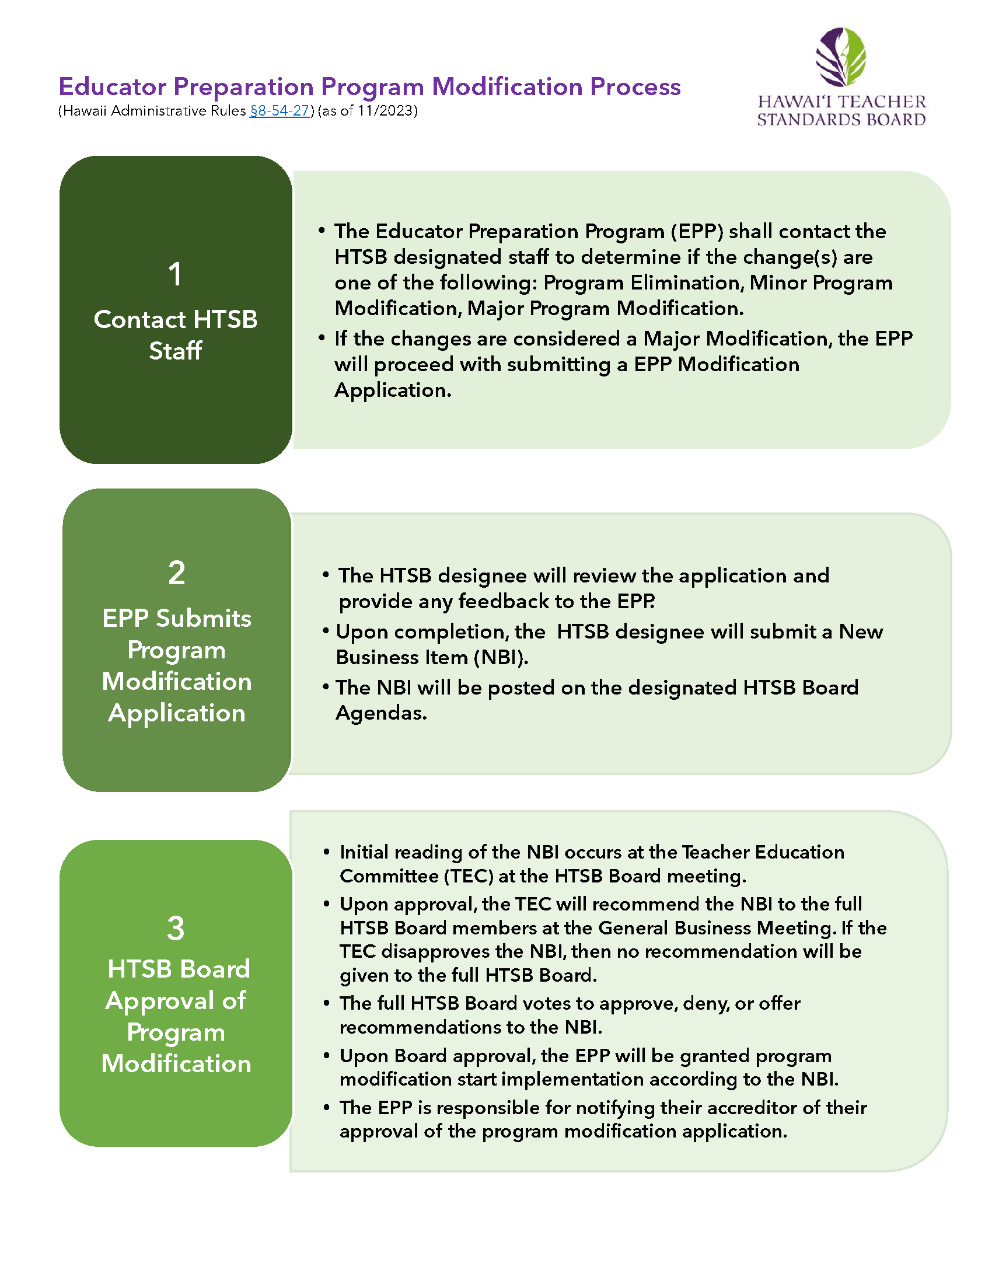

Key Terms

Term | Definition
Add a Field Program | Add a Field programs are designed to prepare existing licensed educators to add another licensure field to their current license.  (§8-54-24).
Alternative Certification Program | Alternative certification program is a for-profit or non-profit organization offering a teacher licensure program for individuals who have earned a baccalaureate degree.
Alternative Route | Teacher preparation programs at institutions of higher education that offer a pathway to initial teacher licensure for individuals who have earned a baccalaureate degree.
Educator Preparation Provider | An organization, college, or university that provides a teacher licensure program for future or current teachers.
Institute of Higher Education | An institution of higher education (IHE) is a college or university that offers post-secondary courses for individuals interested in earning an academic degree.
Teacher Candidate | A college student or an Emergency Hire Teacher enrolled in a teacher education program and pursuing a teacher license.
Traditional Program | A traditional program at an IHE that offers a state-approved teacher education program where teacher candidates will earn an academic degree and teacher licensure recommendation upon successful program completion.

Abbreviations

Abbreviation | Meaning
ACP | Alternative Certification Program
BA | Bachelor of Arts
BS | Bachelor of Science
BEd | Bachelor of Education
EPP | Educator Preparation Provider
HTSB | Hawaiʻi Teacher Standards Board
IHE | Institution of Higher Education
LOI | Letter of Intent
MA | Master of Arts
MEd | Master of Education
MEdT | Master of Education in Teaching
MS | Master of Science
PB-Cert | Post-baccalaureate Certificate
SATEP | State Approved Teacher Education Program
TEC | Teacher Education Committee

EPP Information

Institution Name
Mailing Address
Public URL/Website

Institution Administrator
Title
Email Address
Phone Number

EPP Administrator Name (if different from Institution Administrator)
Position
Phone
Email

EPP Liaison for HTSB Communication
Name
Position
Phone
Email

EPP Change Modification

Mark an X next to the type of EPP Modification(s) requested in this application.
EPP Modification(s) | YES | NO
EPP name
EPP organization/structure
EPP ownership or legal status
EPP vision, mission, and goals

Provide a narrative describing the EPP changes and rationale. Please include the timeframe for these changes and how these changes will impact current staff and students. If needed, upload additional documents as appendices to support your narrative (maximum 500 words).

Provide a narrative on how faculty and students will be informed of the EPP changes in a timely manner. If needed, upload additional documents as appendices to support your narrative (maximum 500 words).

Program Modification

Mark an X next to the type of program modification(s) requested in this application. | YES | NO
Degree level or licensure pathway of the program (e.g., switching from an academic degree to a certificate program, initial licensure to Add a Teaching Field).
Core curriculum (e.g., sequence of instruction, changes in verifying content knowledge, basic skills, and Hawaiʻi specific requirements, adjustment of credit hours for program completion).
Courses (e.g., adding, deleting, replacing courses).
Clinical experiences (e.g., sequence, structure, or length of clinical experience to meet the Hawaiʻi requirement).
Change in grade level band (e.g., adding/removing preschool from elementary education).
Other:

Provide a narrative and rational describing each program modification. Please include the timeframe for these changes and how these changes will impact current staff and students. If needed, upload additional documents as appendices to support your narrative (maximum 500 words).

In the space below, provide a comparison table showing the modification from the existing program to the revised program (see the example below). Submit as appendices, the previous course(s), and new course(s) syllabi as well as other documents to support your narrative.

Example of Course Comparison Modification Table. If needed, you may delete this table.

Current Coursework | Proposed Coursework | Rationale for Course Modification
ED639: Leadership through Action Research for School Improvement | ED417: Educational Foundations and Systems in the United States | Based on course evaluations, post-baccalaureate teacher candidates requested a deeper understanding of school systems since most of them did not have undergraduate degrees in education.
Total Credits: 3 | Total Credits: 3

List of Appendices
Write a title for each appendix you will submit to support the program modification application. Or write not applicable (N/A).
Save each appendix using the file name: InstitutionName_Modification_LicenseFieldName-AppendixLetter_date. Submit each appendix in PDF.

Appendix A:

Appendix B:

Appendix C:

Educator Preparation Program Verification

Preparer’s Information
Name
Position
Telephone Number
Email

Contact person should there be any questions about the application.
Name
Position
Telephone Number
Email

I verify that the contents of this application are complete and accurate, and approved by the institution/organization administrator.
Name
Date

